绝密★启用前 ks5u
2009年普通高等学校招生全国统一考试（安徽卷） ks5u
英 语 ks5u
本试卷分第Ⅰ卷（选择题）和第Ⅱ卷（非选择题）两部分，第Ⅰ卷第1至第l4页，第Ⅱ卷第l5至第l6页。全卷满分l50分，考试时间l20分钟。 ks5u
考生注意事项： ks5u
1. 答题前，务必在试题卷、答题卡规定的地方填写自己的姓名、座位号，并认真核对答题卡上所粘贴的条形码中姓名、座位号与本人姓名、座位号是否一致。务必在答题卡背面规定的地方填写姓名和座位号后两位。 ks5u
2. 答第Ⅰ卷时，每小题选出答案后，用2B铅笔把答题卡上对应题目的答案标号涂黑。如需改动，用橡皮擦干净后，再选涂其他答案标号。 ks5u
3. 答第Ⅱ卷时，必须使用0. 5毫米的黑色墨水签字笔在答题卡上书写，要求字体工整、笔迹清晰。作图题可先用铅笔在答题卡规定的位置绘出，确认后再用0. 5毫米的黑色墨水签字笔描清楚。必须在题号所指示的答题区域作答，超出答题区域书写的答案无效，在试题卷、草稿纸上答题无效。 ks5u
4. 考试结束，务必将试题卷和答题卡一并上交。 ks5u
第Ⅰ卷 ks5u
第一部分 听力（共两节，满分30分） ks5u
回答听力部分时，请先将答案标在试卷上。听力部分结束前，你将有两分钟的时间将你的答案转涂到客观题答题卡上。 ks5u
第一节（共5小题；每小题l. 5分，满分7. 5分） ks5u
听下面5段对话。每段对话后有一个小题，从题中所给的A、B、C三个选项中选出最佳选项，并标在试卷的相应位置。听完每段对话后；你都有10秒钟的时间来回答有关小题和阅读下一小题。每段对话仅读一遍。 ks5u
例：How much is the shirt? ks5u
A. ￡l9. 15. B. ￡9. 15. C. ￡9. 18. ks5u
答案是B。 ks5u
1. What do the speakers need to buy? ks5u
A. A fridge. B. A dinner table. C. A few chairs, ks5u
2. Where are the speakers? ks5u
A. In a restaurant. B. In a hotel. C. In a school. ks5u
3. What does the woman mean? ks5u
A. Cathy will be at the party. ks5u
B. Cathy is too busy to come. ks5u
C. Cathy is going to be invited. ks5u
4. Why does the woman plan to go to town? ks5u
A. To pay her bills in the bank. ks5u
B. To buy books in a bookstore. ks5u
C. To get some money from the bank, ks5u
5. What is the woman trying to do? ks5u
A. Finish some writing. ks5u
B. Print an article. ks5u
C. Find a newspaper, ks5u
【答案】1-5 CBACA
第二节（共l5小题；每小题l. 5分，满分22. 5分） ks5u
听下面5段对话。每段对话后有几个小题，从题中所给的A、B、C三个选项中选出最佳选项，并标在试卷的相应位置。听每段对话前，你将有时间阅读各个小题，每小题5秒钟；听完后，各小题给出5秒钟的作答时间。每段对话读两遍。 ks5u
听第6段材料，回答第6、7题。 ks5u
6. What is the man doing? ks5u
A. Changing seats on the plane. ks5u
B. Asking for a window seat. ks5u
C. Trying to find his seat. ks5u
7. What is the woman's seat number? ks5u
A. 6A. B. 7A. C. 8A. ks5u
【答案】6-7 CB
听第7段材料，回答第8、9题。 ks5u
8. Why doesn’t the woman take the green T-shirt? ks5u
A. It’s too small. B. It’s too dark. C. It’s too expensive. ks5u
9. What does the woman buy in the end? ks5u
A. A yellow T-shin. B. A blue T-shirt. ks5u
C. A pink T-shirt. ks5u
【答案】8-9 AC
听第8段材料，回答第10至12题。 ks5u
10. How long has the man been in London? ks5u
A. One year. ks5u
B. A few years. ks5u
C. A couple of months， ks5u
11. Why did the woman leave her hometown? ks5u
A. To lead a city life. ks5u
B. To open a restaurant. C. To find a job. ks5u
12. Where did the woman come from? ks5u
A. London. B. Arnside. C Lancaster ks5u
【答案】10-12 BCB
听第9段材料，回答第l3至l6题。 ks5u
13. What is a daypack? ks5u
A. A box. B. A bag. C. A lock. ks5u
14. What surprises the girl at school? ks5u
A. A lot of discussions in class. ks5u
B. Teachers giving little homework. ks5u
C. Few students asking questions in class. ks5u
15. At what time of the school term does the conversation most probably take place? ks5u
A. At the end of it. ks5u
B. In the middle of it. ks5u
C. At the beginning of it. ks5u
16. What do we know about the girl? ks5u
A. She is new to the school. ks5u
B. She writes for the school newspaper. ks5u
C. She seldom asks questions in class. ks5u
【答案】13-16 BCCA
听第10段材料，回答第17至20题。 ks5u
17. What does Mr Henry Stone do? ks5u
A. A bank clerk. ks5u
B. A teacher. ks5u
C. A writer. ks5u
18. What does Henry like doing at airports? ks5u
A. Watching people. ks5u
B. Telling stories. ks5u
C. Reading magazines. ks5u
19. What did Henry learn from the newspaper that day? ks5u
A. A valuable suitcase was missing. ks5u
B . A man stole money from a bank. ks5u
C. A woman ran away from home. ks5u
20. Why was the woman at the airport? ks5u
A. She was traveling on business. ks5u
B. She was seeing the man off. ks5u
C. She was leaving for Greece. ks5u
【答案】17-20 CABB
第二部分 英语知识运用（共两节，满分45分） ks5u
第一节 单项填空（共15小题；每小题1分，满分15分） ks5u
从A、B、C、D四个选项中，选出可以填入空白处的最佳选项，并在答题卡上将该项涂黑。 ks5u
例: It is generally considered unwise to give a child he or she wants. ks5u
A. however B. whatever C. whichever D. whenever ks5u
答案是B ks5u
21. We can never expect bluer sky unless we create less polluted world. ks5u
A. a; a B. a; the ks5u
C. the; a D. the; the ks5u
【答案】A
【解析】本题考查冠词的用法,。sky和world是独一无二的,但被形容词修饰,则就有泛指的含义了。
22. – I wonder how much you charge for your services.
-- The first two are free the third costs $30.
A. while B. until
C. when D. before
【答案】A
【解析】考查连词的用法。While在这里表转折,表示”但是”。前两个免费,而第三个则要收费。
23. Daniel's family their holiday in Huangshan this time next week.
A. are enjoying B. are to enjoy
C. will enjoy D. will be enjoying
【答案】D
【解析】本题时态的用法。句后”this time next week”是将来进行时的标志.
24. -- Do you think it's a good idea to make friends with your students?
-- , I do. I think it's a great idea.
A. Really B. Obviously
C. Actually D. Generally
【答案】C
【解析】本题考查副词的用法。.Really真正地,obviously,明显地,Actually,实际上,Generally,一般来说.从句意来看,显然,Actually最符合语境。
25. Just as Professor Scotti often it, success is ninety-nine percent mental attitude.
A. gets B. makes
C. puts D. means
【答案】C
【解析】本题考查动词的区别。put it可作为一常用法。含有”表达”的意思.就像Scotti教授表达那样样,…….
26. -- Could you be so kind as to close the window?
A. With pleasure B. Go ahead
C. Yes, please D. That's OK
【答案】A.
【解析】本题考查交际用语。根据问句.自然选择”with pleasure,很愿意”
27. A good friend of mine from I was born showed up at my home right before I left for Beijing.
A. how B. whom
C. when D. which
【答案】C
【解析】本题考查连词的用法。根据句意，我儿时的一位好朋友到我家里来了。得出答案
28. The play next month aims mainly to reflect the local culture.
A. produced B. being produced
C. to be produced D. having been produced
【答案】C
【解析】本题考查非谓语动词作定语的用法。句中有next month，动词不定式来则表将来。
29. Some people who don’t like to talk much are not necessarily shy；they just be quiet people.
A. must B. may
C. should D. would
【答案】B.
【解析】考查情态动词的用法。前后联系应该为“他们可能是比较安静的人”。
30. Many children， parents are away working in big cities，are taken good care of in the village.
A. their B. whose
C. of them D. with whom
【答案】B
【解析】本题考查定语从句的用法。应为”他们的父母”
31. China has got a good for fighting against the flu with its careful and smooth organization.
A. reputation B. influence
C. impression D. knowledge
【答案】A.
【解析】本题考查名词的用法。四个近义词来区分.从句意及空格后面的介词入手,表达”中国在.....上面有着较好的威望”应接介词for. Influence和.impression后接on.。 Knowledge后则习惯用of.
32. a certain doubt among the people as to the practical value of the project.
A. It has B. They have
C. It remains D. There remains
【答案】D.
【解析】本题考查there be结构. remain替代了to be动词.
33. We tried to find a table for seven，hut they were all .
A. given away B. kept away
C. taken up D. used up
【答案】C
【解析】本题考查动词短语的区别.give away泄露,捐赠. keep away,控制在外. take up占据.use up用光,用尽。根据题意得出答案。
34. But for their help，we the program in time.
A. can not finish B. will not finish
C. had not finished D. could not have finished
【答案】D
【解析】本题考查虚拟语气.根据But for,而选则would/could/might/should+have done结构了.
35. I'm amazed to hear from my school teacher again. ，it is ten years since we met last.
A. In a word B. What’s more
C. That’s to say D. Believe it or not
【答案】D
【解析】本题考查连接词的用法。根据上下文得出。“信不信由你”。
第二节 完形填空（共20小题；每小题1. 5分，满分30分）
阅读下面短文，从短文后各题所给的四个选项（A、B、C、和D）中，选出可以填入空白处的最佳选项，并在答题卡上将该项涂黑。
After spending a weekend away with my adult son, I was so impressed by his generous heart that I sent him this letter. 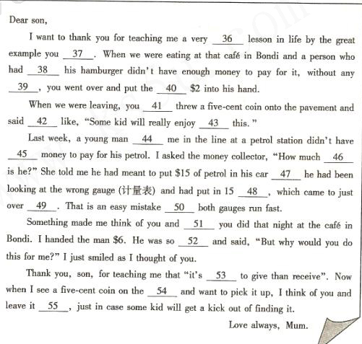
36. A. humorous B. private C. reasonable D. valuable
37. A. followed B. gave C. set D. took
38. A. ordered B. booked C. offered D. bought
39. A. hesitation B. doubt C. permission D. difficulty
40. A. other B. last C. extra D. rest
41. A. again B. already C. only D. also
42. A. nothing B. everything C. anything D. something
43. A. finding B. accepting C. looking for D. pointing at
44. A. behind B. beyond C. ahead of D. next to
45. A. much B. some C. any D. enough
46. A. far B. 1ong C. short D. high
47. A. and B. but C. SO D. while
48. A. 1itres B. kilograms C. pounds D. kilometers
49. A. $15 B. $20 C. $25 D. $30
50. A. until B. as C. although D. unless
51. A. what B. which C. whatever D. whichever
52. A. excited B. surprised C. interested D. encouraged
53. A. easier B. better C. faster D. worse
54.A. comer B. way C. ground D. carpet
55. A. there B. here C. out D. around
36. 【答案】D
【解析】本题考查形容词辨析。humourous 幽默的,private, 私人的, reasonable,合理的.valuable,有价值的。根据句意可得应是有价值的。
37. 【答案】C
【解析】本题考查动词词组辨析。应是词组.set an example to/for sb.
38. 【答案】A
【解析】本题考查动词辨析。order表示当时点餐。 book要于提前预定。offer,主动提供。 Bought购买。应为当时点菜。
39. 【答案】A
【解析】本题考查抽象名词辨析。前后联系“豪不犹豫”去帮助别人。
40. 【答案】C
【解析】本题考查词汇辨析。应是付了额外的2元钱.
41. 【答案】D
【解析】本题考查副词辨析。again,表示”再次”,不能用.already,已经.不合意思.only,仅仅. 和前面冲突.also,也.符合题意.
42. 【答案】D
【解析】本题考查不定代词辨析。句意是“你还说了一些这样的话”。
43. 【答案】A
【解析】本题考查动名词的用法。表示意外发现的结果。
44. 【答案】C
【解析】本题考查词语辨析。应该是站在作者本人前面加油的那位顾客。应该是排对等候。
45.【答案】D
【解析】本题考查不定代词和enough的辨析。表示没有足够钱来付油费。
46. 【答案】C
【解析】本题考查形容词辨析。差多少钱。short表示”欠,缺”常见词组,be short of .
47. 【答案】B
【解析】本题考查词语辨析。表示转折。
48. 【答案】A
【解析】油是用升计量的.
49. 【答案】 B
【解析】本题考查辨别数字（金钱）。加油的人看错了计量表,只有20元最贴近15元了,因为肯定超过15元,不能选A.
50. 【答案】B
【解析】本题考查连词辨析。上下文联系得出。
51. 【答案】A
【解析】本题考查疑问词辨析。宾语从句,what做do的宾语。
52. 【答案】 B
【解析】本题考查形容词辨析。有人主动付款,应是感到非常之惊讶.
53. 【答案】B
【解析】本题考查形容词辨析。这是个谚语.”给予总比接受好”
54. 【答案】C
【解析】本题考查词汇辨析。上下文联系得出答案。
55. 【答案】 A
【解析】本题考查副词辨析。让需要的人去捡。
第三部分阅读理解（共20小题；每小题2分，满分40分）
阅读下列短文，从每题所给的四个选项（A、B、c和D）中，选出最佳选项，并在答题卡上将该项涂黑。
A
Remembering names is an important social skill. Here are some ways to master it.
Recite and repeat in conversation.
When you hear a person’s name，repeat it. Immediately say it to yourself several times without moving your lips. You could also repeat the name in a way that does not sound forced or artificial.
Ask the other person to recite and repeat.
You can let other people help you remember their names. After you’ve been introduced to someone，ask that person to spell the name mad pronounce it correctly for you. Most people will be pleased by the effort you’re making to learn their names.
Admit you don’t know.
Admitting that you can’t remember someone’s name can actually make people relaxed. Most of them will feel sympathy if you say. “I’m working to remember names better. Yours is right on the tip of my tongue. What is it again?”
Use associations.
Link each person yon meet with one thing you find interesting or unusual. For example，you could make a mental note: "Vicki Cheng -- tall, black hair. " To reinforce you’re your associations, write them on a small card as soon as possible.
Limit the number of new names you learn at one time.
When meeting a group of people, concentrate on remembering just two or three names. Free yourself from remembering every one. Few of the people in mass introductions expect you to remember their names. Another way is to limit yourself to learning just first names. Last names can come later.
Go early.
Consider going early to conferences, parties and classes. Sometimes just a few people show up on time. That's fewer names for you to remember. And as more people arrive, you can hear them being introduced to others—an automatic review for you.
56. How will most people feel when you try hard to remember their names?
A. They will be moved. B. They will be annoyed.
C. They will be delighted. D. They will be discouraged.
【答案】C
【解析】本题考查推理判断题。可从第四自然段最后一句话Most people will be pleased by the effort you’re making to learn their names．得出结论。
57. If you can't remember someone's name, you may __
A. tell him the truth B. tell him a white lie
C. ask him for pity D. ask others to help you
【答案】A
【解析】本题考查细节理解题。从第六自然段Admitting that you can’t remember someone’s name can actually make people relaxed．得出答案。
58. When you meet a group of people, it is better to remember __
A. all their names B. a couple of names first
C. just their last names D. as many names as possible
【答案】B
【解析】本题考查主旨大意题。可以从第八自然段的When meeting a group of people, concentrate on remembering just two or three names.得出答案。
59. What does the text mainly tell us?
A. Tips on an important social skill. B. Importance of attending parties.
C. How to make use of associations. D. How to recite and repeat names.
【答案】A
【解析】本题考查推理判断题。浏览全文得出答案。

B
The year 2009 is the Year of Ox. The ox is a representative of the fanning culture of China. In the farming economy （经济）, oxen are the major animals pulling plows （犁）.
Of course, the good of oxen is not limited to plowing. In fact, they are seen as "boats on land" for their ability to carry loads. Besides, the whole body of an ox is full of treasures. Their meat and milk are food full of nutrition, and their skin can be used to make clothes and shoes. With all these qualities, oxen are regarded as generous creatures.
In the past, oxen played an important role in the spiritual life of the Chinese. Even today, oxen still play a special part in some folk activities. For example, some people who1ire in southwest China will cook cattle bone soup and share it among family members when holding the ceremony for children who reach 13. They believe that the cattle bone soup represents the blood relationship among family members. In order to express their love for oxen, people in some other areas will run to shake off diseases on the 16th day of the first month by the lunar calendar （农历）, and during their run they will take their oxen along, which indicates they regard the creature as human.
Because of the contribution of oxen in their lives, the Chinese people are very grateful to the animal. In addition, the use of oxen in ceremonies and the thanks people owe to oxen help to develop various traditional customs, which becomes an important part of the folk culture of the Chinese nation.
60. The words "boats an land" underlined in Paragraph 2 refer to __
A. animals for taking goods B. creatures for pulling plows
C. treasures of the folk culture D. tools in the farming economy
【答案】A
【解析】本题考查细节理解题。从第二自然段Of course, the good of oxen is not limited to plowing.得出答案。
6l. From the third paragraph, we know that __
A. oxen are no more important today than in the past
B. ceremonies are held when people cook cattle bone soup
C. oxen are treated as human in some areas of China
D. people run with oxen to shake off diseases every month
【答案】C
【解析】本题考查细节理解题。可从倒数第二自然段句子people in some other areas will run to shake off diseases on the 16th day of the first month by the lunar calendar (农历), and during their run they will take their oxen along, which indicates they regard the creature as human.得出答案。
62. Which of the following helps to develop traditional customs?
A. The special role of oxen in frowning.
B. People's respect and love for oxen.
C. The practical value of an ox's body.
D. The contribution of oxen to the economy.
【答案】B
【解析】本题考查推理判断题。同样可从倒数第二自然段句子In order to express their love for oxen,…
63. Why does the author write the text?
A. To stress the importance of oxen in farming.
B. To introduce the Chinese folk culture.
C. To describe how to celebrate the Year of Ox.
D. To explain how to develop agriculture with oxen.
【答案】B
【解析】本题考查推理判断题。从最后一自然段得出答案。

C
Sometimes, the simplest ideas are the best. For example, to absorb heat from the sun to heat water, you need large, flat, black surfaces. One way to do that is to build those surfaces specially, on the roofs of buildings. But why go to all that trouble when cities are rub of black surfaces already, in the form of asphalt （柏油） roads?
Ten years ago, this thought came into the mind of Arian de Bondt, a Dutch engineer. He finally persuaded his boss to follow it up. The result is that their building is now heated in winter and cooled in summer by a system that relies on the surface of the road outside.
The heat-collector is a system of connected water pipes. Most of them ran from one side of the street to the other, just under the asphalt road. Some, however, dive deep into the ground.
When the street surface gets hot in summer, water pumped through the pipes picks up this heat and takes it underground through one of the diving pipes. At a depth of 100 metres lies a natural aquifer （蓄水层） into which several heat exchangers （交换器） have been built. The hot water from the street runs through these exchangers, warning the ground-water, before returning to the surface through another pipe. The aquifer is thus used as a heat store.
In winter, the working system is changed slightly. Water is pumped through the heat exchangers to pick up the heat stored during summer. This water goes into the building and is used to warm the place up. After performing that task, it is pumped under the asphalt and its remaining heat keeps the road free of snow and ice.
64. Which of the following is true according to the first two paragraphs?
A. Arian de Bondt got his idea from his boss.
B. Large, flat, black surfaces need to be built in cities.
C. The Dutch engineer's system has been widely used.
D. Heat can also be collected from asphalt roads.
【答案】D
【解析】本题考查排除法理解题。根据前两自然段内容可排除A、B、C。
65. For what purpose are the diving pipes used?
A. To absorb heat from the sun.
B. To store heat for future use.
C. To turn solar energy into heat energy.
D. To carry heat down below the surface.
【答案】D
【解析】本题考查细节理解题。可从第四自然段When the street surface gets hot in summer, water pumped through the pipes picks up this heat and takes it underground through one of the diving pipes.得出答案。
66. From the last paragraph we can learn that __
A. some pipes have to be re-arranged in winter
B. the system can do more than warming up the building
C. the exchangers will pick up heat from the street surface
D. less heat may be collected in winter than in summer.
【答案】D
【解析】本题考查推理判断题。最后一自然段得知。
D
Timetable
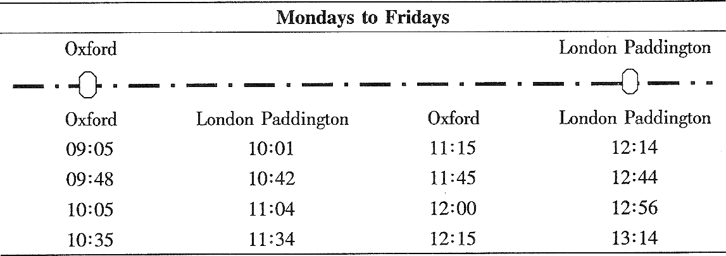
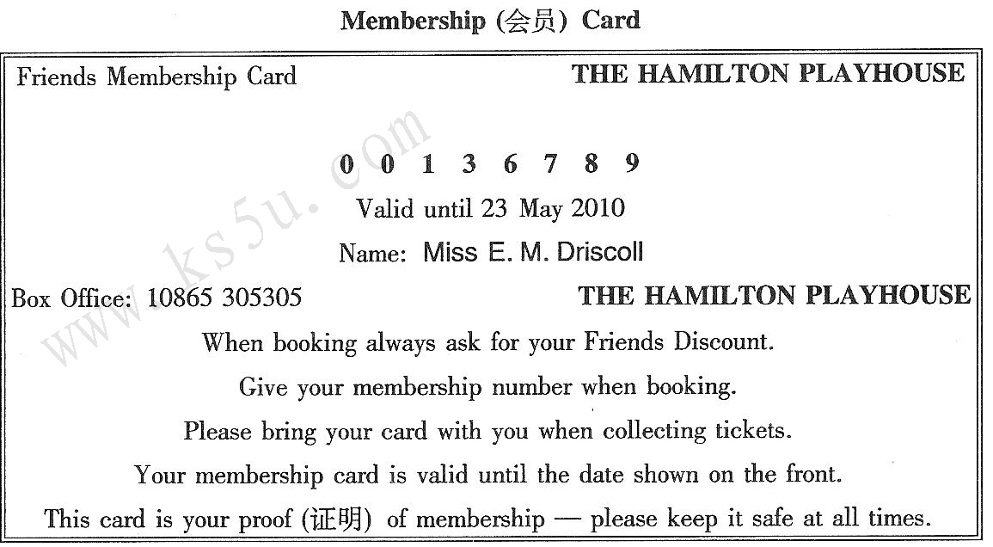
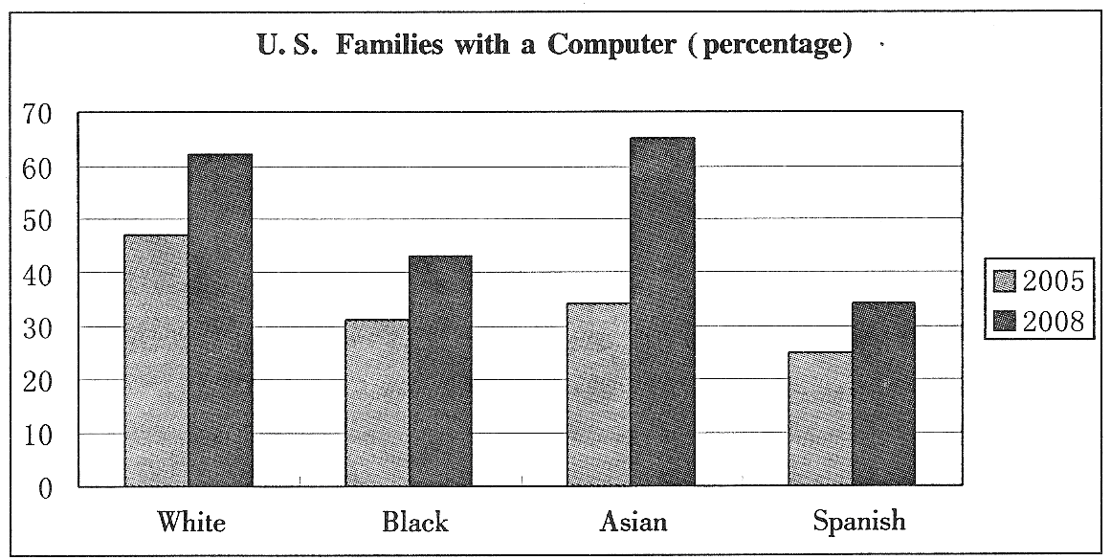
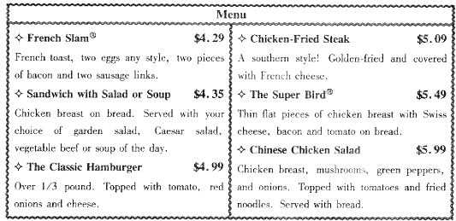
67. What is most likely to be discussed in the paragraph that follows?
A. What we shall do if the system goes wrong.
B. What we shall do if there are no asphalt roads.
C. How the system cools the building in summer.
D. How the system collects heat in spring and autumn.
【答案】C
【解析】本题考查推理判断题。浏览全文得出答案。
68. Which of the following is true of the membership card?
A. Its number is l0865 305305.
B. It belongs to Mr. E. M. Driscoll.
C. It is valid through the year of 2010.
D. It gets the owner a discount when used.
【答案】D
【解析】本题考查推理判断题。浏览全文得出答案。
69. If one wants to attend a business lunch in London at l2：00,the latest train that he should take at Oxford leaves at .
A. 11：45 B. 11：15 C. 10：35 D. 10：05
【答案】C
【解析】本题考查推理判断题。从表一部分的得出答案。
70. If you would like to have some vegetable beef, what may be your choice?
A. French Slam® B. Chicken-Fried Steak®
C. The Super Bird® D. Sandwich with Salad or Soup®
【答案】D
【解析】本题考查细节理解题。从表四内容理解得出。
71. The chart shows that from 2005 to 2008， .
A. the percentage of the Spanish families with a computer rose 35 points
B. the percentage of the White families with a computer remained unchanged
C. the number of the Black families with a computer was on the decrease
D. the number of the Asian families with a computer showed the sharpest increase
【答案】D
【解析】本题考查推理判断题。根据表三图示得出答案。

E
A rainforest is an area covered by tall trees with the total high rainfall spreading quite equally through the year and the temperature rarely dipping below l6℃. Rainforests have a great effect on the world environment because they can take in heat from the sun and adjust the climate. Without the forest cover，these areas would reflect more heat into the atmosphere，warming the rest of the world. Losing the rainforests may also influence wind and rainfall patterns，potentially causing certain natural disasters all over the world.
In the past hundred years，humans have begun destroying rainforests in search of three major resources（资源）：land for crops，wood for paper and other products，land for raising farm animals. This action affects the environment as a whole. For example，a lot of carbon dioxide（二氧化碳）in the air comes from burning the rainforests. People obviously have a need for the resources we gain from cutting trees but we will suffer much more than we will benefit.
There are two main reasons for this. Firstly，when people cut down trees，generally they can only use the land for a year or two. Secondly，cutting large sections of rainforests may provide a good supply of wood right now，but in the long run it actually reduces the world’s wood supply.
Rainforests are often called the world’s drug store. More than 25％ of the medicines we use today come from plants in rainforests. However，fewer than l％of rainforest plants have been examined for their medical value. It is extremely likely that our best chance to cure diseases lies somewhere in the world’s shrinking rainforests.
72. Rainforests can help to adjust the climate because they .
A. reflect more heat into the atmosphere
B. bring about high rainfall throughout the world
C. rarely cause the temperature to drop lower than l6℃
D. reduce the effect of heat from the sun on the earth
【答案】D
【解析】本题考查细节理解题。第一自然段Rainforests have a great effect on the world environment because they can take in heat from the sun and adjust the climate．得出答案。
73. What does the word “this” underlined in the third paragraph refer to?
A. We will lose much more than we can gain.
B. Humans have begun destroying rainforests.
C. People have a strong desire for resources.
D. Much carbon dioxide comes from burning rainforests.
【答案】A
【解析】本题考查细节理解题。第二自然段People obviously have a need for the resources we gain from cutting trees but we will suffer much more than we will benefit.了解到答案。
74. It can be inferred from the text that
A. we can get enough resources without rainforests
B. there is great medicine potential in rainforests
C. we will grow fewer kinds of crops in the gained land
D. the level of annual rainfall affects wind patterns
【答案】B
【解析】本题考查主旨大意题。浏览全文得出答案。
75. What might be the best title for the text?
A. How to Save Rainforests
B. How to Protect Nature
C. Rainforests and the Environment
D. Rainforests and Medical Development
【答案】C
【解析】本题考查推理判断题。浏览全文最终得出答案。

第Ⅱ卷
考生注意事项：
请用0. 5毫米黑色墨水签字笔在答题卡上作答，在试题卷上答题无效。
第四部分写作（共两节，满分35分）
第一节任务型读写（共10小题；每小题1分，满分10分）
阅读下面短文，根据所读内容在表格中的空白处填入恰当的单词。注意：每个空格只填一个单词。
Many people need guidance in choosing a career （职业）. Fortunately, there is much information on the Web about job opportunities （机会）. With all the information available, it's not surprising that people can feel confused. So if you're ready to start your first job or change careers, where do you begin?
The Occupation Handbook is a good resource. Regularly updated, the Handbook is available as a book and on-line. Not only is information provided about the United States as a whole, but readers can easily search for information about their particular state. You can read about the fastest-growing occupations in the area where you live and find out what they are like. You can also learn how to apply for jobs.
Take, for example, Nadia's situation. Nadia was a doctor's assistant in Iran, and her goal in the United States is to become a nurse. However, she needs to work while she is studying nursing. She is interested in becoming a medical assistant to help work her way through college. When going on-line to the Handbook and searching under "medical assistant", Nadia is happy to read that this is expected to be one of the fastest-growing careers through 2010. Besides, job opportunities are even better for people with experience. She discovers that medical assistants not only have to do some office work, but have medical responsibilities as well. Nadia decides this job will be interesting and will also provide excellent experience for her nursing career.
The Occupation Handbook is just an example of websites that can help you plan a new career. When you have found information about some different careers, you will be ready to talk to career advisers. Choosing your future career is an extremely important decision. It's worth taking the time and finding as much information as you can.
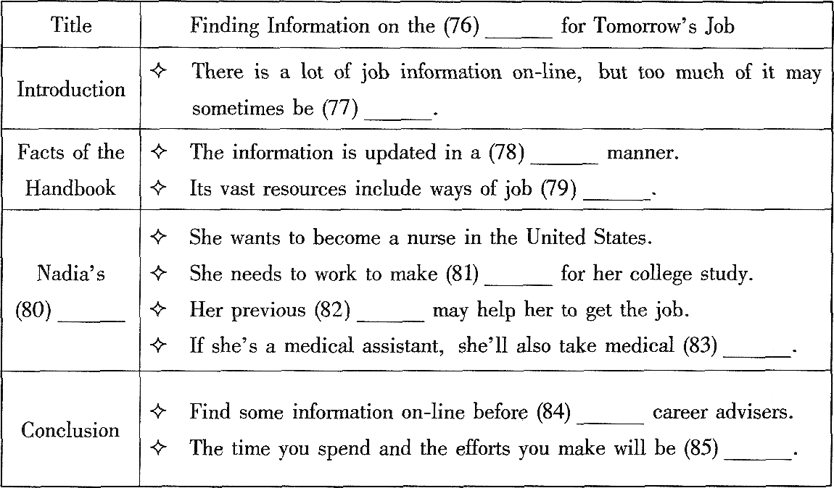【答案】76. Web/Website/Net/Internet 77. confusing
78. regular 79. application
80. Situation 81. money
82. experience 83. responsibilities
84. consulting/asking 85. worthwhile

第二节书面表达（满分25分）
假设你正在参加全省中学生英语演讲比赛，请你针对有些父母经常翻看孩子日记或书包这一现象，写一篇演讲稿，陈述你的观点。
演讲稿的主要内容应包括：
认为同学们不必为此苦恼；
希望能够体谅父母的苦衷；
建议与父母进行交流和沟通。注意：
1. 词数100左右；
2. 可以适当增加细节，以使行文连贯；
3. 开头和结尾已为你写好，不计入总词数。
Good morning, ladies and gentleman.
Some of us are having problems with our parents, as they often look into our school bags or read our diaries.
Thank you!
【参考范文】
Good morning, ladies and gentlemen.
Some of us are having problems with our parents, as they often look into our school bags or read our diaries. I fully understand why we are not comfortable about it, but there’s no need to feel too sad. Our parents are checking our bags or diaries to make sure we’re not getting into any trouble. They have probably heard some horrible stories about other kids and thought we might do the same. Or perhaps they just want to connect with us but are dong it all wrong. My suggestion is: Tell them we want them to trust us as much as we’d like to trust them. If you don’t think you can talk to them, write them a letter and leave it lying around—thy are bound to read it.
Thank you!

