2009高考英语北京卷满分作文

2009-08-18 作者：匿名 来源：网络资源 进入论坛
第一节 情景作文（20分）
假设你是红星中学高三一班的学生李华为响应绿化祖国的号召, 你班四月十二日去郊区植树。请根据一下四幅图的先后顺序, 介绍指数活动的全过程, 给某英文杂志的"绿色行动"专栏写一篇以"Green Action in Our Class"为题的英文稿件。
注意: 字数不少于60。
提示词: 郊区 suburbs
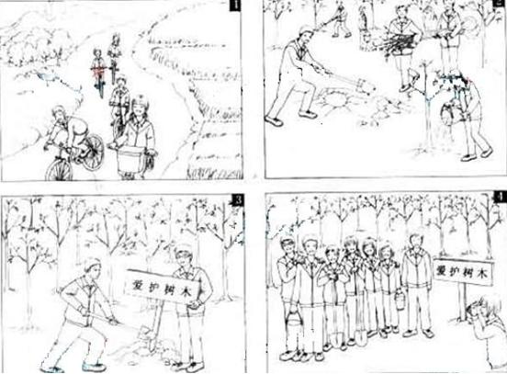
April 12 is memorable because our class had a meaningful experience on that day. In the morning, we bicycled to the suburbs to plant trees, talking and laughing all the way. Upon arrival, we began to work immediately. Some were digging holes. Some were carrying and planting young trees. Others were watering . After getting the work done, we put up a board reminding people to protect the trees. Before leaving we took some photos to record our green action. Seeing the lines of trees, we all had a sense of achievement. We feel it's our duty to protect and beautify our environment.
【名师点评】
本文是设计巧妙的提纲要点式作文，与环保结合，立意较好。文章思路清晰，要点连贯，在语言的表达上选词新颖，同时运用了分词短语作状语等较好的句式表达。
第二节 开放作文（15分）
根据下面提示, 写一篇短文, 字数不少于50.
In your spoken English class, your teacher shows you the following picture. You are asked to describe the picture and explain how you understand it.
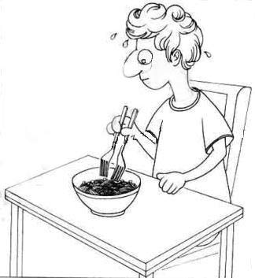
What an interesting picture! A western young man, sitting at a table, is ready to eat a bowl of noodles. He is holding two forks the same way as we Chinese hold chopsticks. He is trying so hard to pick up the noodles that he is sweating a lot. At first glance, I think it's a bit funny, for we Chinese take for granted that chopsticks are the tools for eating noodles. The man in the picture is trying to copy us. Obviously he is doing it the hard way. Maybe using one fork will do a better job, In my opinion, we don't need to copy others' ways of thinking. Sometimes a simpler way of doing things may be a better way.
【名师点评】
本文是开放性作文，要求考生把握好图画内容，发散表达。考生重点要看出这个人是卷发高鼻的外国人，要体会到西式刀叉对中式食物的矛盾性。行文结构十分明晰，同时句式使用得熟练而准确。

