2008年普通高等学校招生全国统一考试 （全国卷I）
英语
第一部分 听力 （共两节，满分30分）
第一节 （共5小题，每小题1.5分，满分7.5分）
听下面5段对话，每段对话后有一个小题，从题中所给的A、B、C三个选项中选出最佳选项，并标在试卷的相应位置，听完每段对话后，你都有10秒钟时间来回答有关小题和阅读下一小题。每段对话仅读一遍。
例：How much is the shirt?
A. ￡19.15 B. ￡9.15 C. ￡9.18
答案是B。
1. What is the weather like?
A. It’s raining. B. It’s cloudy.
2. Who will go to China next month?
A. Lucy. B. Alice. C. Richard.
3. What are the speakers talking about?
A. The man’s sister. B. A film. C. An actor.
4. Where will the speakers meet?
A. In Room 340. B. In Room 314. C. In Room 223.
5. Where does the conversation most probably take place？
A. In a restaurant. B. In an office. C. At home.
第二节 （共15小题；每小题1.5分，满分22.5分）
听下面5段对话或独白，每段对话或独白后面有几个小题，从题中所给的A、B、C三个选项中选出最佳选项，并标在试卷的相应位置。听每段对话或独白前，你将有时间阅读各小题，每小题5秒钟；听完后，各小题将给出5秒钟的作答时间。每段对话或独白读两遍。
听第6段材料，回答第6至8题。
6. Why did the woman go to New York?
A. To spend some time with the baby.
B. To look after her sister.
C. To find a new job.
7. How old was the baby when the woman left New York?
A. Two months. B. Five months. C. Seven months.
8. What did the woman like doing most with the baby?
A. Holding him. B. Playing with him. C. Feeding him.
听第7段材料，回答第9至11题。
9. What are the speakers talking about?
A. A way to improve air quality. B. A problem with traffic rules.
C. A suggestion for city planning.
10. What does the man suggest?
A. Limiting the use of cars. B. Encouraging people to walk.
C. Warning drivers of air pollution.
11. What does the woman think about the man’s idea?
A. It’s interesting. B. It’s worth trying. C. It’s impractical.
听第8段材料，回答第12至14小题。
12. How long will the man probably stay in New Zealand?
A. One week. B. Two weeks. C. Three weeks.
13. What advice does the woman give to the man?
A. Go to New Zealand after Christmas.
B. Book his flight as soon as possible.
C. Save more money for his trip.
14. What can we learn about flights to New Zealand at Christmas time?
A. They require early booking.
B. They can be twice as expensive.
C. They are on special offer.
听第9段材料，回答第15至17题。
15. Why did Jane call Mike?
A. To ask him to meet her.
B. To tell him about Tom.
C. To borrow his car.
16. Where will Jane be in about one hour?
A. At Mike’s place. B. At the airport. C. At a garage.
17. What can we infer from the conversation?
A Jane has just learned to drive.
B. Jane’s car is in bad condition.
C. Mike will go to the airport.
听第10段材料，回答第18至20题。
18. What did the speaker ask the students to do the week before?
A. Write a short story. B. Prepare for the lesson. C. Learn more about the writer.
19. Why does the speaker ask the questions?
A. To check the students’ understanding of the story.
B. To draw the students’ attention to reading skills.
C. To let the students discuss father-son relationships.
20. What will the students do in 10 minutes?
A. Ask more questions. B. Discuss in groups. C. Give their answers.
第二部分 英语知识运用（共两节，满分45分）
- 单项填空（共15小题：每小题1分，满分15分）
从A、B、C、D四个选项中，选出可以填入空白处的最佳选项，并在答题卡上将该项涂黑。
例：We ______ last night, but we went to the concert instead.
A. must have studied B. might study
C. should have studied D. would study
答案是C。
21.—Would you like to join me for a quick lunch before class?
— ______, but I promised Nancy to go out with her.
A. I’d like to B. I like it. C. I don’t D. I will
22.—What fruit is in season now?
—Pears and apples, ______.
A. I know B. I think C. I see D. I feel
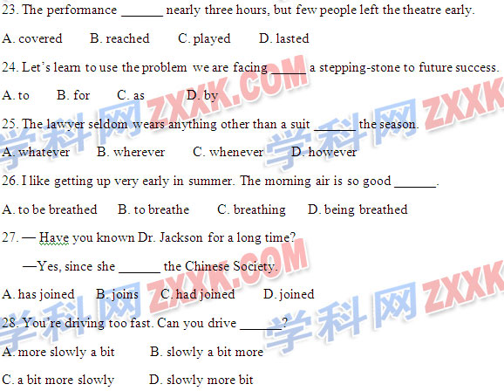29. The wet weather will continue tomorrow when a cold front ______ to arrive.
A. is expected B. is expecting C. expects D. will be expected
30. —Which of the two computer games did you prefer?
—Actually I didn’t like ______.
A. both of them B. either of them
C. none of them D. neither of them
31. —Have you got any idea for the summer vacation?
—I don’t mind where we get ______ there’s sun, sea and beach.
A. as if B. as long as C. now that D. in order that
32. The weather was ______ cold that I didn’t like to leave my room.
A. really B. such C. too D. so
33. The English spoken in the United States is only slightly different from ______ spoken in England.
A. which B. what C. that D. the one
34. After studying in a medical college for five years, Jane ______ her job as a doctor in the countryside.
A. set out B. took over C. took up D. set up
35. —Sorry, I made a mistake again.
— ______. Practice more and you’ll succeed.
A. Never mind B. Certainly not C. Not at all D. Don’t mention it
第二节 完形填空(共20小题，每题1.5分，共30分)
阅读下面短文，撑握其大意，然后从36—55各题所给的四个选项（A、B、C和D）中，选出最佳选项，并在答题卡上将该项涂黑。
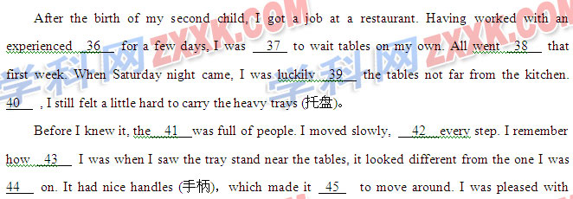everything and began to 46 I was a natural at this job.
Then, an old man came to me and said, “Excuse me, dear, my wife and I loved __47 you work. It seems your tray stand has been very 48 to you, but we are getting ready to 49 now, and my wife needs her 50 back.”
At first his 51 did not get across. “What was he talking about!” Then I got it. I had set my trays on his wife’s orthopedic walker (助步器). I stood frozen as ice, but my face was 52 . I wanted to get into a hole and 53 .
Since then, I have learned from many mistakes such as the one I just 54 , I have learned to be more 55 and not to be too sure of myself.
36. A. manager B. assistant C. cook D. waitress
37. A. promised B. invited C. allowed D. advised
38. A. well B. quickly C. safely D. wrong
39. A. left B. given C. brought D. shown
40. A. Therefore B. However C. Otherwise D. Finally
41. A. kitchen B. street C. restaurant D. table
42. A. minding B. changing C. taking D. saving
43. A. angry B. calm C. sad D. happy
44. A. fixed B. trained C. loaded D. waited
45. A. slower B. lighter C. quieter D. easier
46. A. believe B. agree C. regret D. pretend
47. A. letting B. making C. watching D. having
48. A. useful B. familiar C. unusual D. interesting
49. A. rest B. order C. eat D. leave
50. A. bag B. walker C. tray D. coat
51. A. idea B. praise C. message D. need
52. A. cold B. full of joy C. pale D. on fire
53. A. lie B. hide C. defend D. stay
54. A. repeated B. discovered C. corrected D. described
55. A. careful B. patient C. honest D. practical
第三部分 阅读理解(共20小题;每小题2分，满分40分)
阅读下列短文，从每题所给的四个选项（A、B、C和D）中，选出最佳选项，并在答题卡上将该项涂黑。
A
Last week my youngest son and I visited my father at his new home in Tucson, Arizona. He moved there a few years ago, and I was eager to see his new place and meet his friends.
My earliest memories of my father are a tall, handsome, successful man devoted to his work and his family, but uncomfortable with his children. As a child I loved him. He seemed unhappy with me unless I got straight A’s and unhappy with my boyfriends if their fathers were not as “successful” as he was. Whenever I went out with him on weekends, I used to struggle to think up things to say, feeling on guard.
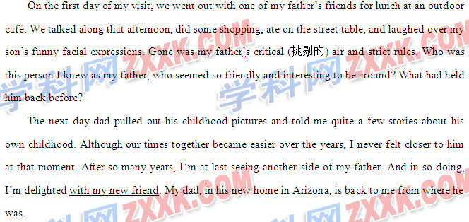56. Why did the author feel bitter about her father as a young adult?
A. He was silent most of the time.
B. He was too proud of himself.
C. He did not love his children.
D. He expected too much of her.
57. When the author went out with her father on weekend, she would feel .
A. nervous B. sorry C. tired D. safe
58. What does the author think of her father after her visit to Tucson?
A. More critical. B. More talkative
C. Gentle and friendly. D. Strict and hard-working.
59. The underlined words “my new friend” in the last paragraph refer to .
A. the author’s son B. the author’s father
C. the friend of the author’s father D. the café owner
B
More than 10 years ago, it was difficult to buy a tasty pineapple (菠萝). The fruits that made it to the UK were green on the outside and, more often than not, hard with an unpleasant taste within. Then in 1966, the Del Monte Gold pineapple produced in Hawaii first hit our shelves.
The new type of pineapple looked more yellowy-gold than green. It was slightly softer on the outside and had a lot of juice inside. But the most important thing about this new type of pineapple was that it was twice as sweet as the hit-and-miss pineapples we had known. In no time, the Del Monte Gold took the market by storm, rapidly becoming the world’s best-selling pineapple variety, and delivering natural levels of sweetness in the mouth, up until then only found in tinned pineapple.
In nutrition (营养) it was all good news too. This nice tasting pineapple contained four times more vitamin C(维生素C) than the old green variety. Nutritionists said that it was not only full of vitamins, but also good against some diseases. People were understandably eager to be able to buy this wonderful fruit. The new type of pineapple was selling fast, and the Del Monte Gold pineapple rapidly became a fixture in the shopping basket of the healthy eater.
Seeing the growing market for its winning pineapple, Del Monte tried to keep market to itself. But other fruit companies argued successfully that Del Monte turned to law for help, but failed. Those companies argued successfully that Del Monte’s attempts to keep the golden pineapple for itself were just a way to knock them out the market.
60. We learn from the text that the new type at pineapple is __________.
A. preen outside and sweet inside
B. good-looking outside and soft inside
C. yellowy-gold outside and hard inside
D. a little soft outside and sweet inside
61. Why was the new type of pineapple selling well?
A. It was rich in nutrition and tasted nice.
B. It was less sweet and good for health.
C. It was developed by Del Monte.
D. It was used as medicine.
62. The underlined word “fixture” in Paragraph 3 probably refers to something _________.
A. that people enjoy eating B. that is always present
C. that is difficult to get D. that people use as a gift
63. We learn from the last paragraph that Del Monte _________.
A. slowed other companies to develop pineapples
B. succeeded in keeping the pineapple for itself
C. tried hard to control the pineapple market
D. planned to help the other companies
C
It is often necessary to release a fish, that is , set it free after catching, because it is too small, or you just don’t want to take it home to eat. In some cases, releasing fish is a good measure that will help keep fish variety and build their population size. The Department of Game and Inland Fisheries (DGIF) encourages fishermen who practice catch-and-release fishing to use a few simple skills when doing so. The advice provided below will help make sure that the fish you release will survive (存活) to bite again another day.
—When catching a fish, play it quickly and keep the fish in the water as much as possible.
Don’t’ use a net in landing the fish and release it quickly to prevent it from dying.
—Hold the fish gently. Do not put your fingers in its eyes. Don’t wipe the scales (鱼鳞) off the fish because it might cause it to develop a disease and reduce its chance of survival.
—Remove your hook (鱼钩) quickly. If the hook is too deep or hooked in the stomach, cut the line and leave the hook in. The hook left inside will cause no serious problem to the fish.
—Take good care of the fish by moving it gently in water . Release the fish when it begins to struggle and is able to swim.
—Do not hold fish in a bucket or some other containers and later decide to release it. If you are going to release a fish, do so right away.
With a little care and by following the suggestions given above, you can give the released fish a better chance of survival.
64. People sometimes set a fish free after catching it because they _________
A. don’t want it to die B. hope it will grow quickly
C. don’t want to have it as food D. want to practice their fishing skills
65. Which of the following will probably make a fish ill?
A. Taking the hook off it. B. Removing its scales.
C. Touching its eves D. Holding it in your hand.
66. A proper way to release a fish is to _________.
A .move it in water till it can swim B. take the hook out of its stomach
C. keep it in a bucket for some time D. let it struggle a little in your hand
67. What is the purpose of the test?
A. To show how to enjoy fishing. B. To persuade people to fish less often.
C. To encourage people to set fish free. D. To give advice on how to release fish.
D
Holidays
Holiday News
Vacancies (空位) now and in the school holidays at a country hotel in Devon. This comfortable, friendly home-from-home lies near the beautiful quiet countryside, but just a drive away from the sea. The food is simple but good. Children and pets are welcome.
Reduced prices for low season.

The Snowdonia Center
The Snowdonia Center for young mountain climbers has a mountain 1068.The beginners’ costs are ￡57 for a week, including food and rooms. Equipment is included except walking shoes, which can be hired at a low cost.
You must be in good health and prepared to go through a period of body exercises. This could be the beginning of a lifetime of lifetime of mountain climbing adventure.

The World Sea Trip of a Lifetime
Our World Sea Trip of 2008 will be unlike any holiday you have ever been on before. Instead of one hotel after another, with all its packing and unpacking waiting and traveling, you just go to bed in one country and wake up in another.
On board the ship, you will be well taken care of. Every meal will be first-class and every cabin like your home.
During the trip, you can rest on deck(甲板), enjoy yourself in the games rooms and in the evening dance to our musical team and watch our wonderful play.
You will visit all the places most people only dream about – from Acapulco and Hawaii to Tokyo and Hong Kong.
For a few thousand pounds, all you’ve ever hoped for can be yours.
- What can you do if you like to go on holidays with pets?
  - Choose the holiday in Devon.
  - Go to the Snowdonia Centre
  - Join the World Sea Trip of 2008
  - Visit Acapulco and Hawaii
- In what way is the Snowdonia Centre different from the other two holidays?
  - It provides chances of family gatherings.
  - It provides customers with good food.
  - It offers a sport lesson.
  - It offers comfortable room.
70. What is special about the World Sea Trip of 2008?
A. You can have free meals on deck every day.
B. You can sleep on a ship and tour many places.
C. You will have chances to watch and act in a play.
D. You have to do your own packing and unpacking.
71. At the Snowdonia Centre, the beginners’ costs of ￡57 do not cover .
A. food B. rooms C. body exercises D. walking shoes
E
Edward Wilson is America’s, if not the world’s, leading naturalist. In The Future of Life, he takes us on a tour of the world’s natural resources(资源). How are they used? What has been lost? What remains and is it able to continue with the present speed of use? Wilson also points out the need to understand fully the biodiversity(生物多样性)of our earth.
Wilson begins with an open letter to the pioneer in environment (环境) protection, Henry David Thoreau. He compares today’s Walden Pond with that of Thoreau’s day. Wilson will use such comparisons for the rest of the book. The problem is clear: man has done great damage to his home over the years. Van the earth, with human help, be made to return to biodiversity levels that will be able to support us in the future?
Biodiversity, Wilson argues, is the key to settling many problems the earth faces today. Even our agricultural crops can gain advantages from it. A mere hundred species(物种) are the basis of our food supply, of which but twenty carry the load. Wilson suggests changing this situation by looking into ten thousand species that could be made use of, which will be a way to reduce the clearing of the natural hoes of, plants and animals to enlarge farming areas.
At the end of the book, Wilson discusses the importance of human values in considering the environment. If you are to continue to live on the earth, you may well read and act on the ideas in this book.
72. We learn form the text that Wilson cares most about ______
A. the environment for plants B. the biodiversity of our earth
C. the wastes of natural resources D. the importance of human values
73. How many species are most important to our present food supply?
A. Twenty. B. Eighty. C. One hundred D. Ten thousand.
74. Wilson suggests that one way to keep biodiversity is to _______.
A. learn how to farm scientifically
B. build homes for some dying species
C. make it clear what to eat
D. use more species for food
75. We can infer that the text is _______
A. a description of natural resources
B. a research report
C. a book review
D. an introduction to a scientist.
第二卷
第四部分 写作（共两节，满分35分）
第一节 短文改错（共10小题，每题1分，满分10分）
Dear Alice,
I have just got some good mews to tell to you. 76. ______
I win a national prize for painting last week. 77. ______
My father was so pleasing that he suggested 78. ______
I go to England for a holiday. I’d like to staying 79. ______
There for half a month, visiting place of interest 80. ______
Or practicing my English as well. We’ve been 81. ______
Writing to each for nearly a year now. I have 82. ______
often dreamed of talk face to with you. 83. ______
I imagine you’ll be at vacation yourself by that 84. ______
Time. Perhaps we could go out to do some 85. ______
sightseeing together.
Best,
Lily
第二节 书面表达（满分25分）
假定你是李华，从小喜爱大熊猫（panda）,一直通过有关网站(website)关注三年前在美国圣迭哥动物园出生的大熊猫“苏琳”和她的母亲“白云”。现在苏琳即将三岁。请根据以下要点给动物园工作人员写一封信：
- 自我介绍；
- 祝贺苏琳生日；
- 感谢工作人员；
- 索取苏琳三岁生日照。
注意：1、词数100左右；
2、可以适当增加细节，以使行文连贯；
3、开头语已为你写好。
Dear Sir/Madam,
Greetings from China!
__________________________________________________________________________
______________________________________________________________________________
______________________________________________________________________________
______________________________________________________________________________
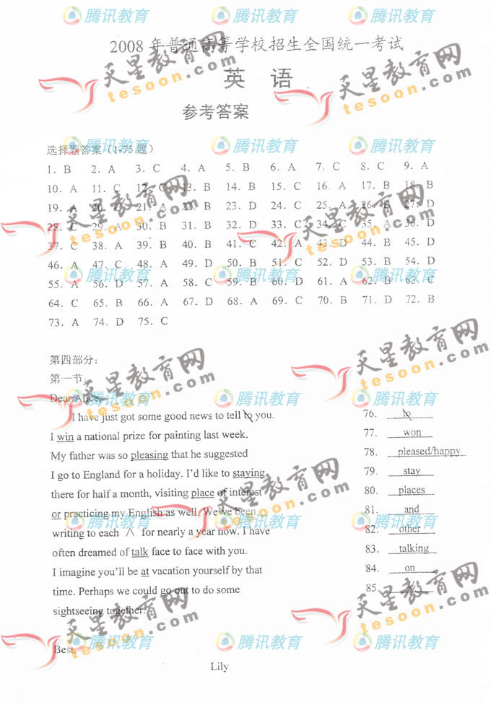
Yours truly,
Li Hua

