2007年普通高等学校招生全国统一考试（福建卷）
英语试卷

第Ⅰ卷（选择题共115分）
第一部分 听力（共两节，满分30分）
做题时，先将答案标在试卷上。录音内容结束后，你将有两分钟的时间将试卷上的答案转涂到答题卡上。
第一节 （共5小题；每小题1.5分，满分7.5分）
听下面5段对话。每段对话后有一个小题，从题中所给的A、B、C三个选项中选出最人佳选项，并标在试卷的相应位置。听完每段对话后，你都有10秒钟的时间来回答有关小题和阅读下一小题。每段对话仅读一遍。
例：How much is the shirt?
A.￡19.15. B.￡9.15 C.￡9.18
答案是B。
1．Who is coming for tea?
A.John. B.Mark. C.Tracy.
2．What will the man do next?
A.Leave right away. B.Stay for dinner. C.Catch a train
3．What does the man come for?
A.A lecture. B.A meeting. C.A party.
4．What size does the man want?
A.9. B.35. C.39.
5．What are the speakers talking about?
A. Life in Southeast Asia B. Weather conditions. C.A holiday tour.
第二节 （共15小题；每小题1.5分，满分22.5分）
听下面5段对话或独白。每段对话或独白后有几个小题，从题中所给的A、B、C三个选项中选出最佳选项，并标在试卷的相应位置。听每段对话或独白前，你将有时间阅读各个小题，每小题5秒钟；听完后，各小题将给出5秒钟的作答时间。每段对话或独白读两遍。
听第6段材料，回答第6、7题。
6．What is the man doing?
A. Giving a speech. B. Chairing a meeting. C. Introducing a person.
7．Why does the woman sing so well?
A. She has a great teacher. B. She teaches singing. C. She is young.
听第7段材料，回答第8、9题。
8．What is the second gift for Jimmy?
A.A car. B.A watch. C.A computer.
9．Why does Jimmy feel happy?
A.He lives with his parents.
B.He’s got what he dreamt of.
C.He’s received lots of presents.
听第8段材料，回答第10至12题。
10．What is the relationship between the speakers?
A. They are friends.
B. They are strangers to each other.
C. They are husband and wife
11．Why does the woman come to talk with the man?
A. To get a job. B. To take a test. C. To see the secretary.
12．What does the man mean by saying sorry?
A. He can’t hear the woman clearly.
B. He doesn’t need a designer.
C. He can’t help the woman.
听第9段材料，回答第13至16题。
13．What do we know about the woman?
A. She lives close to the office.
B. She is new to the company.
C. She likes the big kitchen.
14．How does the man go to work?
A. On foot. B. By bus. C. By car
15．Why was Susan late for work?
A. She missed the bus.
B. Her train was late.
C. Her car broke down.
16．What will the man do the next day?
A. Go to work by train. B. Visit Lily in her flat. C. Leave home earlier.
听第10段材料，回答第17至20题。
17．Where can you most probably hear this talk?
A.In a class of the English language.
B.In a class of the Greek language.
C.In a class of the French language.
18．How long does the class last?
A.11 weeks. B.13 weeks. C.15 weeks.
19．What is “the short-cut” to learning words according to the speaker?
A.Taking more courses.
B.Reading basic words aloud.
C.Learning how words are formed.
20．Why is the class popular?
A.It is not offered each term.
B.It’s taught by Professor Morris.
C.It helps to master some useful rules.
第二部分 英语知识运用（共两节，满分45分）
第一节 单项填空（共15小题；每小题1分，满分15分）
从A、B、C、D四个选项中，选出可以填入空白处的最佳选项，并在答题卡上将该项涂黑。
例：It is generally considered unwise to give a child he or she wants.
A.however B.whatever C.whichever D.whenever
答案是B。
21．—I saw Jane and her boyfriend in the park at eight yesterday evening.
—Impossible. She TV with me in my home then.
A.watched B.had watched C.would watch D.was watching
22．—How about Christmas evening party?
—I should say it was success.
A.a; a B.The; a C.a;不填 D.the; 不填
23．The book is of great value. can be enjoyed unless you digest it.
A.Nothing B.Something C.Everything D.Anything
24．Jenny hopes that Mr. Smith will suggest a good way to have her written English in a short period.
A.improved B.improving C.to improve D.improve
25．My MP4 player isn’t in my bag. Where I have put it?
A.can B.must C.should D.would
26．—Come on, please give me some ideas about the project.
—Sorry. With so much work my mind, I almost break down.
A.filled B.filling C.to fill D.being filled
27．The village has developed a lot we learned farming two years ago.
A.when B.which C.that D.where
28．—Excuse me, do you have the time?
—
A.Yes, I do B.Of course, I have
C.A quarter to ten D.No problem
29．You will be successful in the interview you have confidence.
A.before B.once C.until D.though
30．Danny hard for long to realize his dream and now he is popular.
A.works B.is working
C.has worked D.worked
31．—You are always full of . Can you tell me the secret?
—Taking plenty of exercise every day.
A.power B.strength C.force D.energy
32．Although my opinion, the old professor didn’t come up with his own.
A.against B.on C.for D.in
33．The news of the mayor’s coming to our school for a visit was on the radio yesterday.
A. tumed out B.found out C.given out D. carried out
34．—Do you need any help, Lucy?
—Yes, The job is I could do myself.
A.less than B.more than
C.no more than D.not more than
35．It is none of your business other people think about you. Believe yourself.
A.how B.what C.which D.when
第二节 完形填空（共20小题；每小题1.5分，满分30分）
阅读下面短文，从短文后所给各题的四个选项（A、B、C和D）中，选出可以填入空白处的最佳选项，并在答题卡上将该项涂黑。
I grew up in a tiny Baltimore row house in a faraway mountain area. My parents 36 the necessities of life 37 they couldn’t give much more. If I asked my father 38 a pair of jeans, he would say, “If you want them, make the money and buy them 39 .” He wasn’t being mean; he just couldn’t 40 them. From age 12 on, I did part-time jobs after school.
When I 41 from high school, I joined the navy. Soon I was in a boot camp(新兵训练营) at Parris Island, S. C., where I learned that life in the navy centered around completing daily
42 . These could be anything from cleaning the camp to conducting mock(模拟的) battles. Completing these tasks successfully 43 discipline, team-work and responsibility. It didn’t
44 whether you were black, white or Asian; everyone worked together for the 45 of the company.
I went 46 to graduate from the U.S. Naval Academy and later became an officer in the navy. The part of my job I 47 most was the consoling(咨询) meetings I 48 with the family members of the men and women in my 49 , trying to help them deal with the long periods of 50 . These proved popular and word of them spread. 51 I was being asked to give encouraging 52 to business groups, educators and kids across the country.
But I consider the boot camp my first real 53 , and my life is still guided by the
54 lessons I learned there. It taught me discipline, friendship and the pride related to setting a task every day and working hard to 55 it.
36．A.provided B.got C.made D.bought
37．A.while B.but C.so D.or
38．A.about B.with C.for D.of
39．A.themselves B.ourselves C.yourself D.myself
40．A.pay B.find C.produce D.afford
41．A.came B.returned C.escaped D.graduated
42．A.drills B.tasks C.exercises D.reports
43．A.included B.asked C.required D.met
44．A.matter B.mean C.exist D.work
45．A.good B.boss C.rest D.right
46．A.out B.on C.away D.off
47．A.took B.hated C.enjoyed D.did
48．A.ended B.began C.continued D.held
49．A.charge B.situation C.position D.choice
50．A.lessons B.meetings C.training D.separation
51．A.Long before B.Before long C.As usual D.Once again
52．A.performances B.descriptions C.speeches D.gifts
53．A.vacation B.place C.job D.travel
54．A.important B.bitter C.normal D.difficult
55．A.gain B.achieve C.show D.match
第三部分 阅读理解（共20小题；每小题2分，满分40分）
阅读下列短文，从每题所给的四个选项（A、B、C和D）中，选出最佳选项，并在答题卡上将该项涂黑。
A
When I met him, I had a lot of anger inside of me. I’ve lived my whole life in Spanish Harlem, but in my neighborhood, there are shoot-ups all the time. I know kids who have been shot or beaten up. I have friends who ended up in prison. I could have ended up that way, too, but
Mr. Clark wouldn’t let that happen.
Mr. Clark worked long hours, making sure I did my work. My grades rose. In fact, the scores of our whole class rose. One day, he took our class to see The Phantom of the Opera, and it was the first time some kids had ever been out of Harlem. Before the show, he treated us to dinner at a restaurant and taught us not to talk with our mouths full. We did not want to let him down.
Mr. Clark was selected as Disney’s 2000 Teacher of the Year. He said he would draw three names out of a hat; those students would go with him to Los Angeles to get the award. But when the time came to draw names, Mr. Clark said, “You’re all going.”
On graduation day, there were a lot of tears. We didn’t want his class to end. In 2001, he moved to Atlanta, but he always kept in touch.. He started giving lectures about education, and wrote a bestselling book based on his classroom rules, The Essential 55. In 2003, Mr. Clark took some of us on a trip to South Africa to deliver school supplies and visit orphanages(孤儿院). It was the most amazing experience of my life. It’s now my dream to one day start a group of women’s clubs, helping people from all backgrounds.
56．Without Mr. Clark, the writer .
A．might have been put into prison
B．might not have won the prize
C．might have joined a women’s club
D．might not have moved to Atlanta
57.The Essential 55 is .
A．a show
B．a speech
C．a classroom rule
D．a book
58．How many students’names were finally drawn out of a hat by Mr. Clark?
A．None
B．Three
C．Fifty-five.
D．All.
59．In the passage, the writer intends to tell us that .
A．Mr. Clark went to South Africa because he liked traveling
B．Mr. Clark helped to set up a group of women’s clubs
C．a good teacher can help raise his or her students’ scores
D．a good teacher has a good influence on his or her students
B
A small town in southwest Britain is banning(禁止) plastic bags in an attempt to help the environment and cut waste－a step that environmentalists believe is a first for Europe.
Shopkeepers in Modbury population 1,500, agreed to stop handing out disposable plastic bags to customers on Saturday. They said paper sacks and cloth carrier bags would be offered instead.
Last month, San Francisco became the first U.S. city to ban plastic grocery bags. Internationally, laws to discourage the use of plastic bags have been passed in parts of South Africa and Ireland, where governments either tax shoppers who use them or fine companies that hand them out. Bangladesh already bans them, and so do at least 30 remote Alaskan villages.
Modbury, about 225 miles southwest of London, has also declared a bag amnesty(宽限期), allowing local people to hand in plastic bags that have piled up at home. They will be sent for a reveling.
The Modbury ban was the idea of Rebecca Hosking, who saw the effect of bags on mane life while working in the Pacific as a wildlife camerawoman. She said response(反应) in the town so far had been “really positive”.
“Modbury is quite an old-fashioned town and a lot of people have wicker baskets to go out shopping anyway,” Hosking told Sky News Television.
The Worldwatch Institute, an environmental research agency, states that 100 billion plastic bags are thrown away each year in the United States alone. More than 500 billion are used yearly around the world.
60．What was Rebecca Hosking?
A．A lawyer.
B．An environmentalist.
C．A sailor.
D．A photographer.
61．The underlined word “disposable” in the passage probably means .
A．acceptable
B．valuable
C．throw-away
D．long-lasting
62．It can be inferred from the passage that .
A．most of the people in Modbury continue to use plastic bags
B．fewer and fewer plastic bags will be used in the world.
C．San Francisco is the first city to ban plastic bags in the world
D．most countries in the world have passed laws to ban plastic bags
63．Which of the following would be the best title of the passage?
A．Environmental Protection
B．Big Cities Banning Plastic Bags
C．Effect of Plastic Fags on Sea Animals
D．British Town Banning Plastic Bags
C
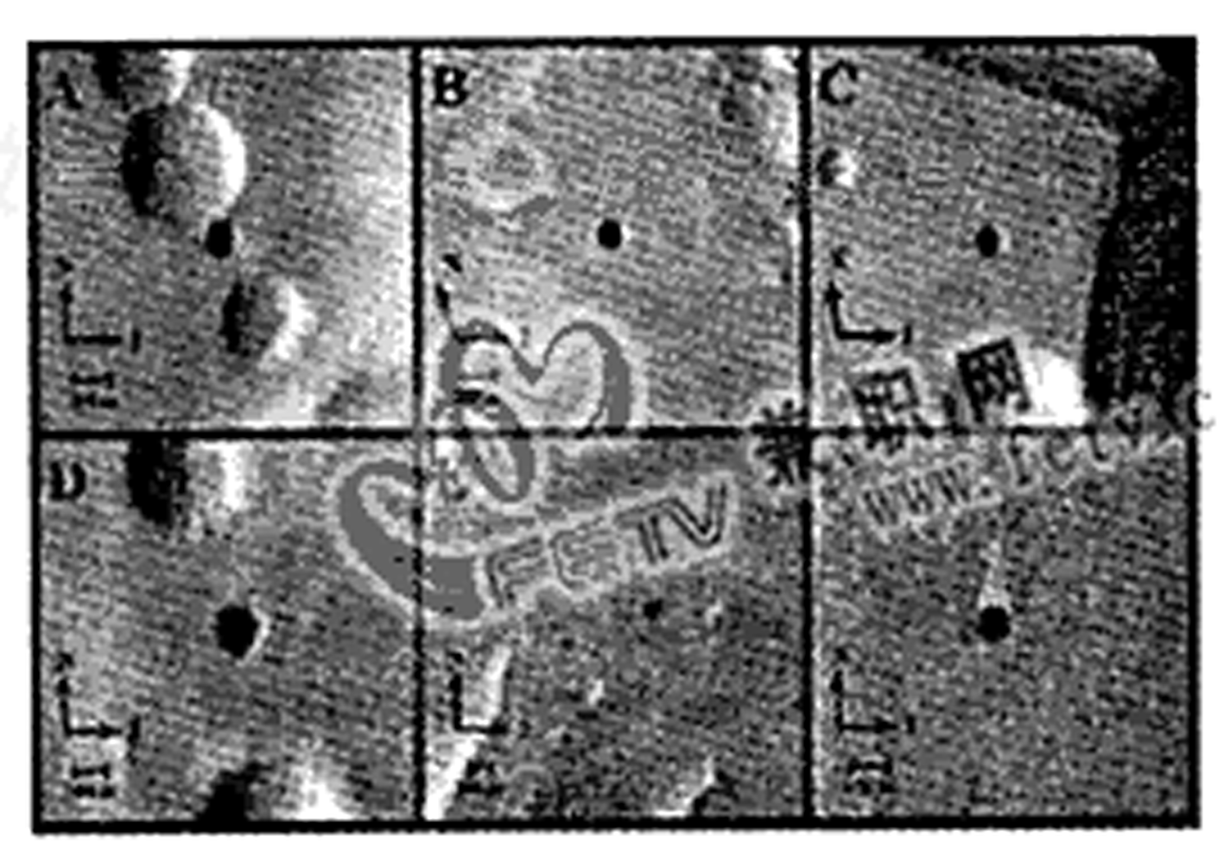
Scientists have found what look like caves on Mars(火星), and say they could be protecting life from the planet’s terrible environment.
The first caves discovered beyond the Earth appear as seven mysterious black dots on the pictures sent back by NASA’s Mars Odyssey orbiter. Each as large as a football field, they may be openings into natural caves below the Martian surface.
“If there is life on Mars, there is a good chance you’d find it in caves,” said Jut Wynne, one of the researchers who noticed the features while working on a US Geological Survey Mars Cave Detection Program.
Jonathan Clarke, a geologist with the Mars Society of Australia, yesterday described the discovery as exciting.
One photo taken at night by an infrared imager(红外线成像器) showed one hole to be unusualy warm, suggesting hot air trapped during the day is flowing out.
“I said:‘Wow, that’s a cave’, ” Dr. Clarke said excitedly. “People have been looking for these for a long time; now we have found them.”
He agreed such caves would be perfect places to hunt for life escaping from the bitterly cold, radiation-soaked(充满辐射的), dry surface.
“Tiny drops of water could collect inside,” he said. “If there are gases coming out, they could provide energy for a whole range of bacteria. A cave is also a protection from radiation; the surface of Mars is exposed to high levels of space radiation.”
The caves probably formed when tube-shaped lave flows(管状岩浆流) spread across the planet long ago. The outside of the tubes cooled, forming solid walls, while something hotter inside allowed the remaining have to flow out, forming caves.
64．What does the passage mainly talk about?
A．How the caves were formed on Mars.
B．How scientists found these caves on Mars.
C．Caves on Mars may be full of hot air or a sign of life.
D．Scientiste have completely recognized the surface of Mars.
65．We can learn from the passage that .
A．water has already been found on Mars
B．the scientists found all the caves at night
C．it is certain that there is life in these caves
D．the surface of Mars is bitterly cold, radiation-soaked and dry
66．According to the passage, Dr. Clarke was so excited because .
A．such caves could provide energy for life
B．they had finally found the caves on Mars
C．such caves would be perfect places to hunt for life
D．scientists had long been looking for these caves
67．Necessary conditions for life on Mars mentioned in the passage may include .
A．lava and energy
B．water and radiation from space
C．gases and lava
D．water and protection from radiation
D

68．The best title of the 3^{nl} advertisement would be
A．Training at Home
B．Learning at Home
C．Recording Work
D．Working at Home
69．According to the information above, if your child has hearing problems, you can turn to .
A．At-Home Profession Corp.
B．Globe Insurance Company
C．Bradford Publications
D．American Inventors Corp.
70．From the advertisements above, we can learn that .
A．Globe Insurance Company has a history of 51 years
B．as a medical transcriptionist, you may earn $ 25,000 a month
C．Bradford Publications offers a treatment to hearing impaired parents
D．you can visit www. aic. com when you invent a new model of hearing aid
E
Dogs wag(摇摆) their tails in different directions depending on whether they are excited and wanting to move forward or threatened and thinking of moving back, a study has found.
Researchers in Italy examined the tail wagging behaviour of 30 dogs, catching their responses to a range of stimuli(刺激物) with video cameos. To conduct the study they chose 15 male dogs and 15 female ones aged between one and six years. The dogs were all family pets whose owners had allowed them to take part in the experiment at Bari Umversity. The dogs were placed in a large wooden box with an opening at the front to allow for them to view various stimuli. They were tested one at a time.
The researchers led by Professor Giorgio Vallortigara of the University of Trieste found that when the dogs were shown their owners—a positive experience—their tails wagged energetically to the right side. When they were shown an unfamiliar human they wagged to the right, but with somewhat less enthusiasm. The appears of a cat again caused a right-hand side wag, although with less intensity again. The appearance of a large unfamiliar dog, similar to a German shepherd, changed the direction of tail wagging to the left. Researchers supposed the dog was thinking of moving back. When the dogs were not shown any stimuli they tended to wag their tails to the left, suggesting they preferred company. While the changes in the tail wagging were not easily noticed without the aid of video, it was thought that the findings could help people judge the mood (心情) of dogs. Computer and video systems, for example, could be used by professional dog trainers to determine the mood of dogs that they were required to approach.
71．The video cameras were used to catch the dogs’ responses because .
A．it was easier to catch the dogs’response changes in the tail wagging
B．the dogs were put in the wooden boxes and tested one at a time.
C．they enabled the dogs’owners to know about their dogs’habit
D．the dogs wagged their tails in different directions when they were in different moods
72．The underlined word“intensity” in the passage means .
A．surprise
B．worry
C．excitement
D．interest
73．When there are no stimuli, a dog will .
A．wag to the left
B．wag to the right
C．not wag at all
D．wag to the left and then to the right
74．The underlined word “they” refers to .
A．the dogs
B．the trainers
C．the systems
D．the researchers
75．The purpose of doing the experiment is .
A．to train dogs for their owners
B．to help people judge the mood of dogs
C．to help dogs find company
D．to help people choose their pet dogs
第Ⅱ卷（非选择题共35分）
第四部分 写作（共两节，满分35分）
第一节 短文改错（共10小题；每小题1分，满分10分）
此题要求改正所给短文中的错误。对标有题号的每一行作出判断：如无错误，在该行右边横线上画一个勾（√）；如有错误（每行只有一个错误），则按下列情况改正：
此行多一词：把多余的词用斜线（\）划掉，在该行右边横线上写出该词，并也用斜线（\）划掉。
此行缺一个词：在缺词处加一个漏字符号（∧）,在该行右边横线上写出该加的词。
此行错一个词：在错的词下划一横线，在该行右边横线上写出改正后的词。
注意：原行没有错的不要改。
短文改错
May 10,2007 Fine
Toady I was having a PE lesson while I fell down 76.
and hurt my foot. I was in greatly pain at that moment, 77.
but I tried to act as if nothing has happened until the 78.
class was over. Though I had difficulty walk back to 79.
my classroom, I still didn’t tell anyone but even refused 80.
the offer of help of my classmates. As result, the hurt 81.
in my foot became worse. Now I know I’m wrong. We 82.
can tell others our need for help and accept his help. 83.
Some day we can not help others in return. In this way, 84.
we can get along to each other happily and peacefully. 85.
第二节 书面表达（满分25分）
假设你是林华，福建省某中学高三学生，请你根据以下学生会倡议书的内容给某英文报社写一封信，叙述拟开展活动的内容并发表自己的看法。
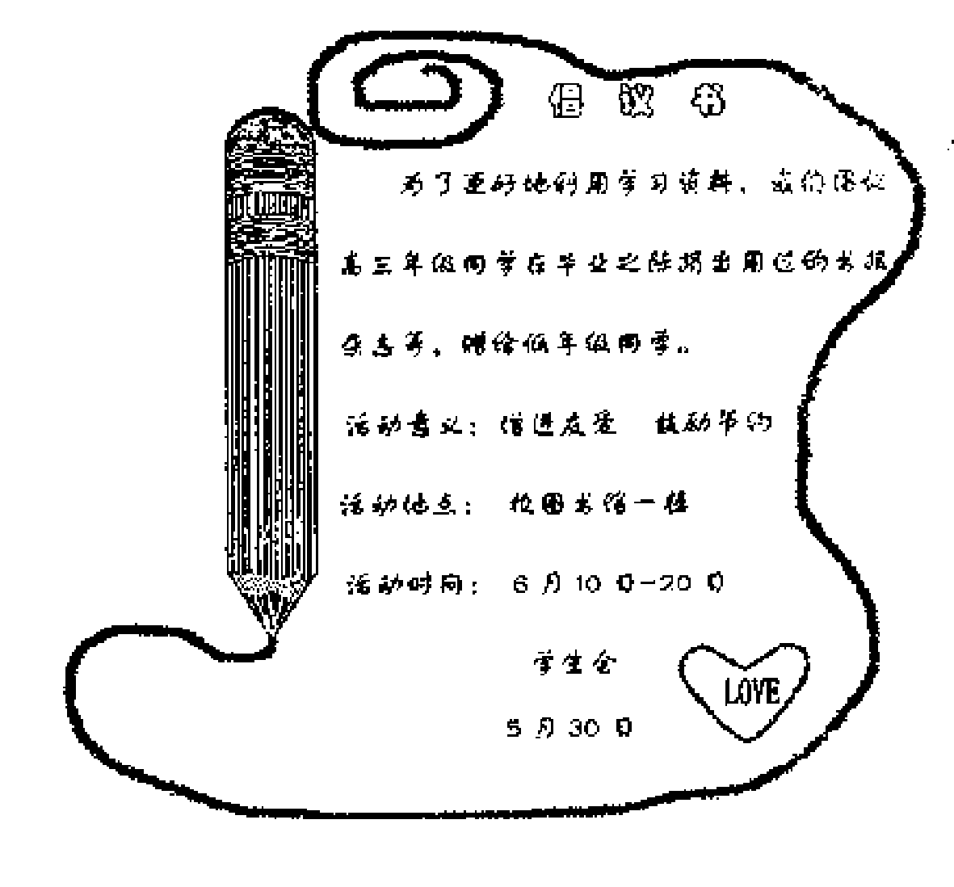
注意：1．信的开头语已经给出，不计入总词数；
2．可根据内容要点适当发挥，但不要逐条翻译；
3．词数100左右：
4．参考词汇：增进promote;鼓励节约encourage economy
Dear editor,
I am a student of Senior Tree in a middle school in Fujian Province.
Yours sincerely,
Lin Hua

